
Client Information Sheet

A Study of Osteoarthritis Management in Dogs Undergoing a Six-Week Program of Patient-Specific Physiotherapy

What is the purpose of the study?
The study will evaluate the improvement in weight bearing, range of motion and quality of life in dogs with osteoarthritis over a six-week tailored physiotherapy program. In doing so, we hope to determine whether six weeks of physiotherapy results in significant improvements in dogs with osteoarthritis.

Why have I been asked to participate in this study?
You have been asked to participate as your dog meets the inclusion criteria for this study. These include having a diagnosis of osteoarthritis and a referral to The Queen’s Veterinary Hospital for physiotherapy. The full inclusion and exclusion criteria may be discussed if you’d like more information.

What will it involve on my part?
We ask that you fill in a short questionnaire (approximately 5 minutes) based on your dog’s mobility and lifestyle at three timepoints across the six-week program. To ensure the integrity of this study, we request that you provide accurate information regarding your dog’s progress and the extent to which you are able to follow the home care suggestions provided to you by the veterinary physiotherapist.

What measurements will you take from my dog?
Non-invasive measurements such as weight bearing and range of motion will be used to monitor your dog’s response to the physiotherapy program. The procedures to take these measurements pose no discomfort or risk to your dog. Measurements will be taken prior to starting the physiotherapy program, midway through and at the end of the six-week course. No additional visits are required to the hospital as all measurements can be taken during your routine scheduled physiotherapy appointment.
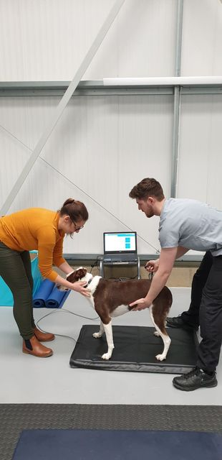

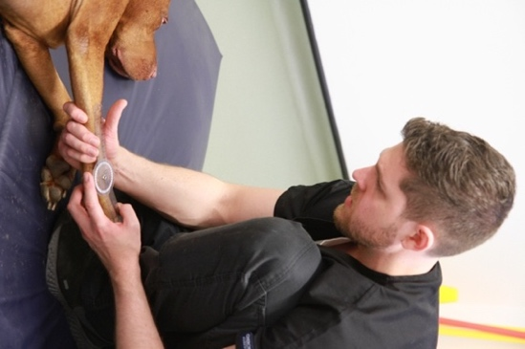
Stance analyser: measures how your dog distributes its weight across its limbs when standing.

Goniometry: measures joint angles to assess range of motion.



What’re the benefits of participation?
There is no cost for the additional assessment measures taken as part of this study. You will receive a summary of your dog’s results shortly after completing the six-week physiotherapy course. We hope this information will provide insight into your dog’s individual response to physiotherapy but also help contribute to a wider evidence base for osteoarthritis management in dogs undergoing a course of physiotherapy.

What will happen to the data?
All data collected from this study will be anonymised and analysed as part of a VetMB student project. This means individual dogs and owners will not be identifiable.

If you have any further queries regarding this study, please contact Hanna Lewis (veterinary student) at hll50@cam.ac.uk or Matthew Scott (veterinary physiotherapist) at physiotherapy@vet.cam.ac.uk.

