**STUDY PROTOCOL SUMMARY**

**EFFECTIVENESS OF LOW-LEVEL LASER THERAPY FOR THE TREATMENT OF OSTEOARTHRITIS-ASSOCIATED PAIN IN DOGS**

This study will improve our scientific knowledge on treatment of osteoarthritis-associated pain in dogs. Osteoarthritis (OA) is a very common problem that negatively affects the quality of life of the affected dogs. Laser treatment is successfully used to treat OA-associated pain in humans and there is some evidence that this may be the case also for dogs; however, further research is needed to consolidate previous findings and build stronger scientific evidence on the usefulness of laser for treatment of canine OA.

Suitable candidates for participating to this trial are dogs with a radiographic diagnosis of OA who are unlikely to be particularly stressed in the hospital environment. We will be looking particularly at **shoulder/elbow OA**, although dogs with multiple affected joints may be included in the absence of recent acute changes to the other affected joints.

Ideally, during the study period the dogs ‘physical exercise should not be strictly limited to short walks on the lead, and intermittent access to open spaces for at least some minutes per day is desirable. This will be useful to differentiate increases in voluntary activity hopefully as a result of laser therapy.

We expect most of the study dogs to be already on treatment with pain killers, in which case this will not be discontinued but potentially adjusted, if applicable/necessary, based on clinical improvement and occurrence of side effects.

**DOG OWNER’S COMMITMENT AND VISITS TO THE HOSPITAL**

As dog owner, you will be asked to sign an informed consent and you will be blind to the treatment protocol. Although your dog is expected to receive laser treatment at some point during the study period, you will not know on which days your dog will be treated until your last visit to the hospital, when this information will be disclosed to you. This will help us to minimise biases caused by subjective assessment.

Overall, the study period will last 8-10 weeks, depending on the treatment protocol assigned to your dog. During the first two weeks after enrolment, none of the study dogs will receive any laser treatment in order to record the baseline activity of each dog. During this time, we won’t need you to do anything except perhaps monitoring that the accelerometry device (see below for details) is still in place. After that, we will need each study dog to be brought to the hospital for visits of 30-60 minute of duration; the frequency of both the visits to the hospital and treatments will vary based on the treatment protocol, with a maximum number of visits of 14 within the 8-10-week period.

We understand this will be quite a commitment for most dog owners, however the schedule will be flexible depending on owner’s availability.

**PRE-TREATMENT ASSESSMENTS**

On their first visit after enrolment, the dogs will be instrumented with a light weight accelerometry monitoring device usually mounted on the dog’s neck collar. It is small and should be worn day and night until the end of the study period, except during swimming if this applies to your dog (although light rain won’t be a problem). Additionally, we will ask you to fill in two validated questionnaires which will help us to better understand how painful and uncomfortable your dog is owing to his/her condition. It has been demonstrated that the owner’s perception of his/her dog’s pain is a powerful tool and an important part of the veterinary assessment, therefore we will value very much your opinion. During the study period, we will ask you to fill in the questionnaires every week.

Your dog will also need to undergo a gait analysis, a sophisticated tool for orthopaedic assessment that will help us to better characterise the lameness of each specific dog. Gait analysis will imply walking on a treadmill (at an increasing speed to a maximum of 6 km/h) for a few minutes, and will be performed either on the day of the dog’s first visit or anytime during the following two weeks. The gait analysis will be repeated at the end of the study period for comparison, for a total of two tests. We will try to combine this with your last visit to the hospital so that you won’t have to come back another time. Although gait analysis is completely non-invasive, dogs with severe OA who struggle with simple everyday movements (e.g., slow-pace short walks) may not cope well with that. If you think this applies to your dog, we may opt not to include him/her in the study not to cause him/her discomfort.

We may advice blood tests if this is applicable. This usually applies to elderly dogs under long term medical treatment with pain killers that may, on the long term, damage the renal and liver function. In this case, we will ask your permission to measure inflammatory cytokines on the residual blood collected from your dog. We may repeat blood tests at the end of the study period if there is a clinical indication to do so (e.g., medical treatment with pain killers was continued and there is a clinical indication to re-check renal and liver parameters). We will **NOT** collect any blood from your dog without your permission and if there is no clinical indication for a blood test.

**TIMETABLE**

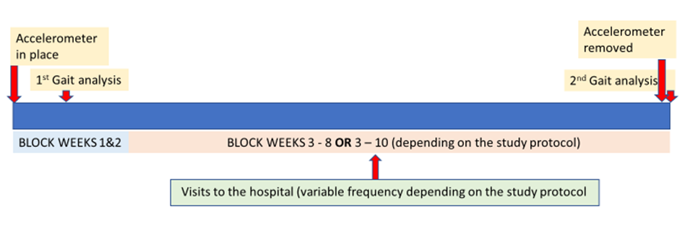

**LASER THERAPY**

We will use a level-4 laser device specific for medical use and with a software and treatment mode very specific for canine OA.

A point-to-point modality with the handpiece will be selected for each treated joint. Black phototypeset will be selected for dark skin as well as for pink skin with dark coat. The handpiece will be held perpendicular to the skin at 0.5-1 cm distance from the skin. The hair will be separated manually prior to application in order to maximise skin exposure. Clipping will be considered only in the presence of thick undercoat hair (e.g., in German Shepherds), which may cause reflectance and therefore decrease the laser power on the target areas.

The joints of interest (shoulder and elbow, lateral and medial sides) will be treated as in the figures below.

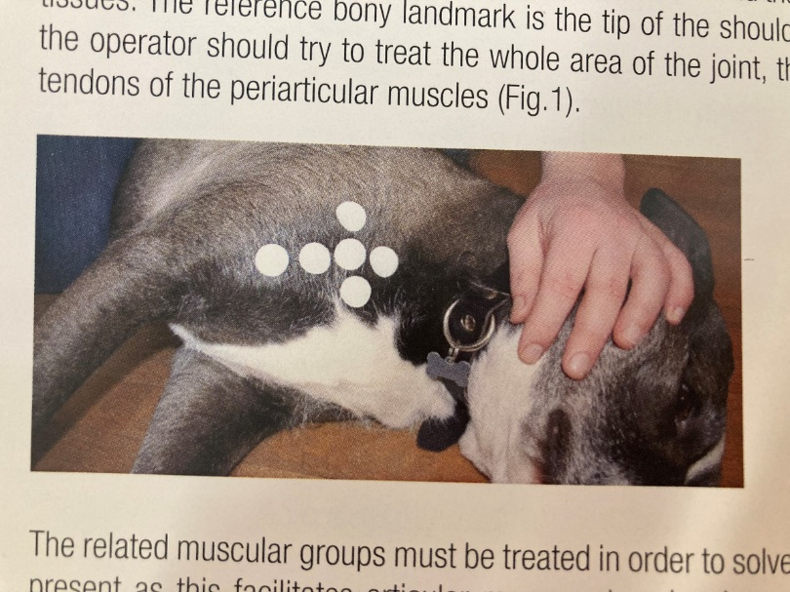 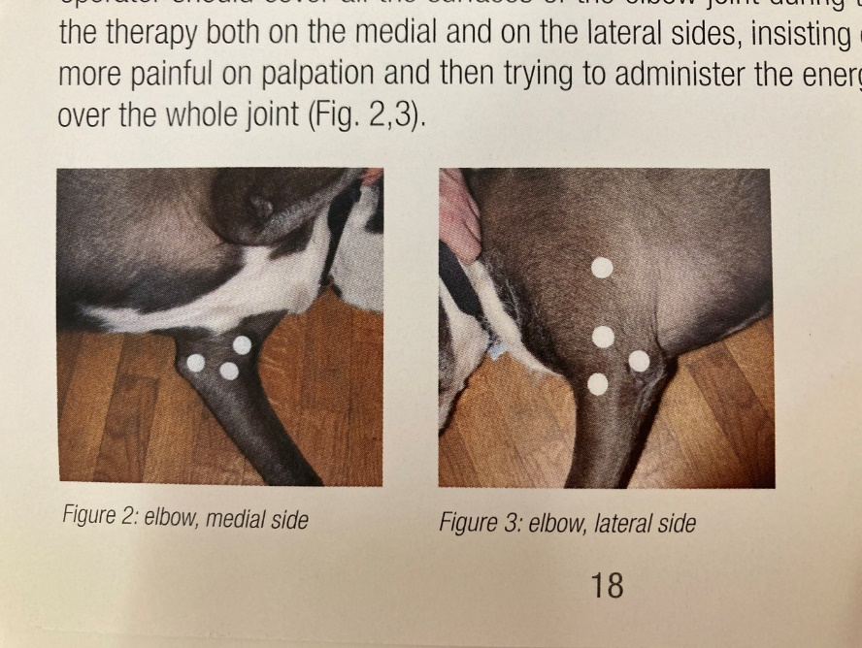 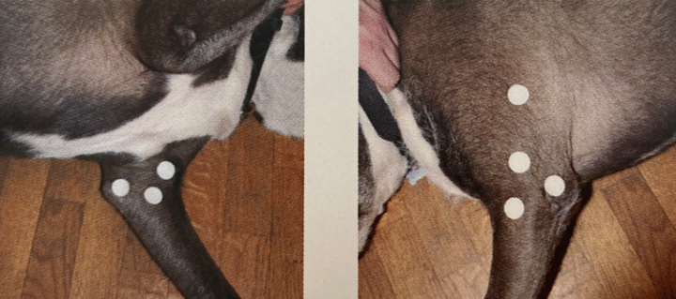

**OTHER RELEVANT INFORMATION**

The study grant will cover all the procedures (consultation with the pain clinician, hospital admission fees, gait analysis, laser treatment, blood tests where appropriate). Unfortunately, there will be no refund for your travel expenses.

**POTENTIAL SIDE EFFECTS OF LASER THERAPY**

Laser therapy is well-tolerated in humans and dogs and side effects are mild and uncommon. Mild increase in local temperature and transient, mild discomfort immediately after the treatment have been described in humans. Your dog will wear protective glasses to protect his/her eyes during the treatment sessions.

If you have any question regarding this clinical trial, please feel free to contact:

*Professor Chiara Adami*

*DMV, FRCVS, Dip. ACVAA, Dip. ECVAA, FHEA, PhD*

*Teaching Professor (Veterinary Anaesthesia and Analgesia)*

*Department of Veterinary Medicine, University of Cambridge*

[ca573@cam.ac.uk](mailto:ca573@cam.ac.uk)